Part 1.
Task 1:

(1)

SELECT COUNT(*) AS num_players
FROM ATHLETE2
WHERE CCODE = 'AUS';

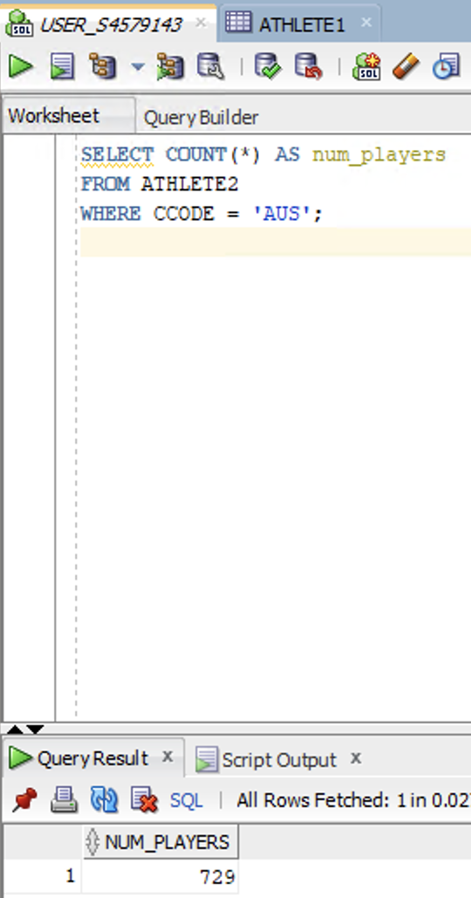

(2)

SELECT SPORTID, COUNT(*) AS num_players
FROM ATHLETE3
WHERE CCODE = 'RUS'
GROUP BY SPORTID;

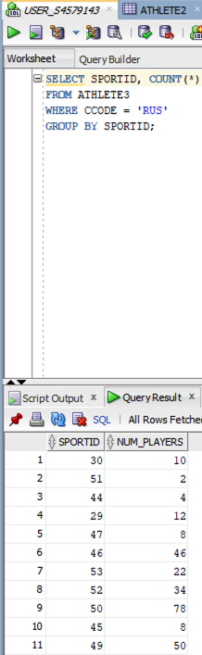

(3)

CREATE TABLE ATHLETE_FULL AS
SELECT * FROM ATHLETE1
UNION ALL
SELECT * FROM ATHLETE 2
UNION ALL
SELECT * FROM ATHLETE 3;

SELECT COUNT(*)
FROM ATHLETE_FULL af
JOIN Country c ON af.CCODE = c.CCODE
WHERE c.CONTINENT = 'EU';

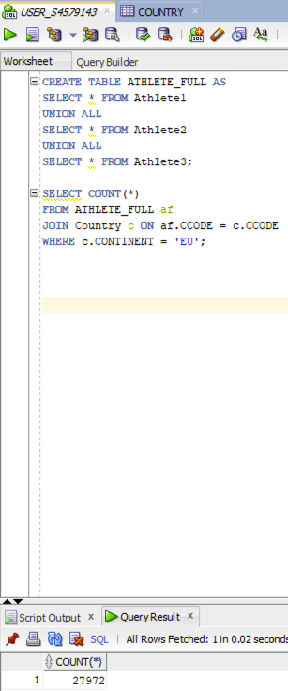

Part 2.
Task 2:

- Full Replication

-- Connect to USER1_HF_FULL_S4579143, USER2_HF_FULL_S4579143, and USER3_HF_FULL_S4579143 and execute the SQL queries/transactions below.

UPDATE ATHLETE1 SET CCODE = 'AUS' WHERE ATHLETEID = 305;
UPDATE ATHLETE2 SET CCODE = 'AUS' WHERE ATHLETEID = 305;
UPDATE ATHLETE3 SET CCODE = 'AUS' WHERE ATHLETEID = 305;

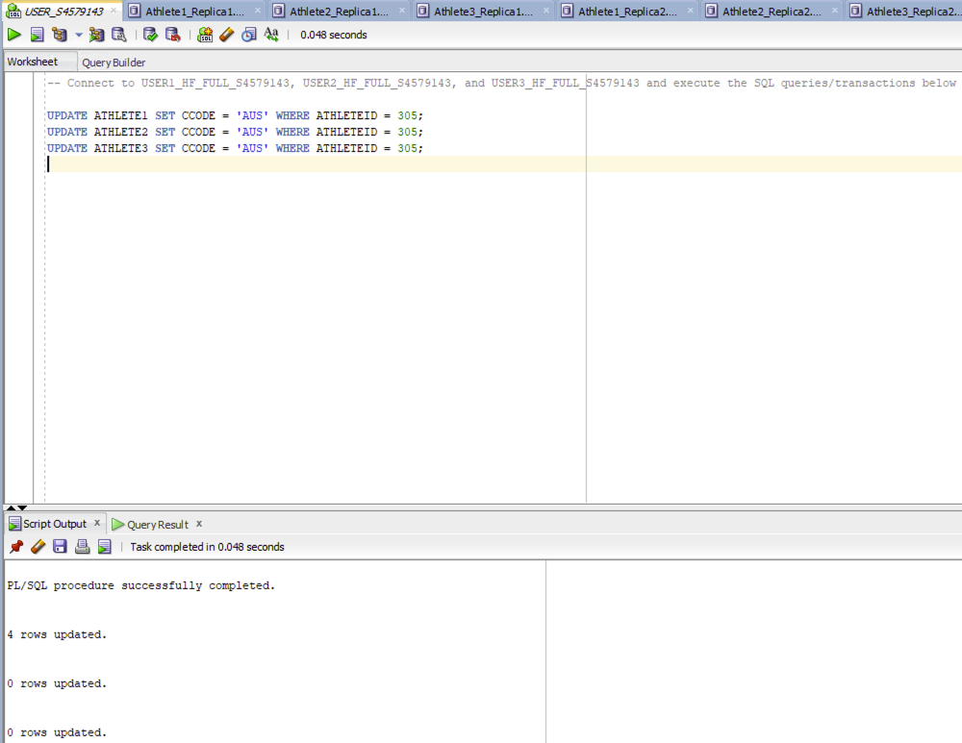

- Partial Replication

-- Connect to USER1_HF_PA_S4579143 and execute the SQL queries/transactions below.

UPDATE ATHLETE1 SET CCODE = 'AUS' WHERE ATHLETEID = 305;

-- Connect to USER2_HF_PA_S4579143 and execute the SQL queries/transactions below.

UPDATE ATHLETE1 SET CCODE = 'AUS' WHERE ATHLETEID = 305;

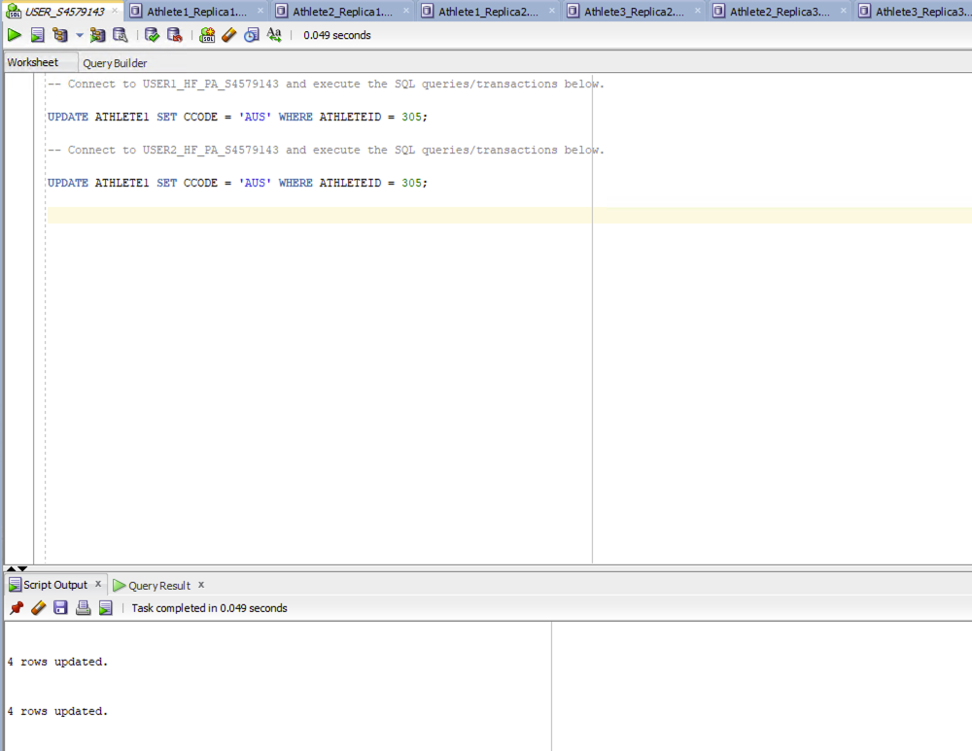

- No Replication

-- Connect to USER1_HF_NO_S4579143 and execute the SQL queries/transactions below

UPDATE ATHLETE1 SET CCODE = 'AUS' WHERE ATHLETEID = 305;

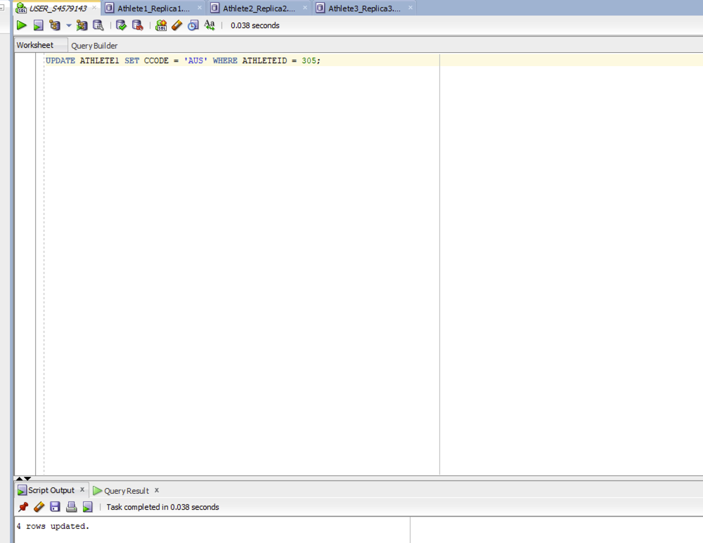

- Explanation

Full Replication: The country code (CCODE) for the athlete with the ID = 305 (ATHLETEID) is updated in all the sites.

Partial Replication: The country code (CCODE) for the athlete with the ID = 305 (ATHLETEID) is updated in only the sites where the fragment copy of the athlete with the ID = 305 (ATHLETEID) is in.

No Replication: The country code (CCODE) is updated only in the sites where the fragment of the athlete with the ID = 305 (ATHLETEID) is in.

Task 3:

SELECT V1.ATHLETEID, V1.FNAME, V1.SNAME, V2. BDATE
FROM ATHLETE_V1 V1
JOIN ATHLETE_V2 V2 ON V1.ATHLETEID = V2.ATHLETEID
WHERE V1. ATHLETEID BETWEEN 305 AND 310;

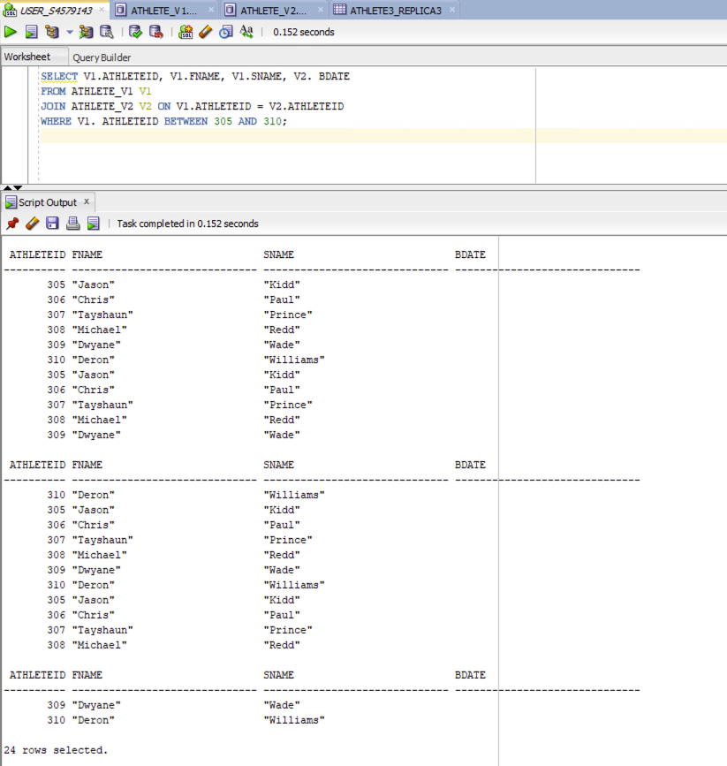

Part 3.
Task 4:

/* Enable Timing */

SET TIMING ON;

/* Enable Statistics */

SET AUTOTRACE ON STATISTICS;

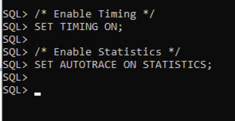

- Inner-join Execution Plan

SELECT b.ATHLETEID, b.FNAME, b.SNAME, c.BDATE, c.CCODE, c.SPORTID
FROM "USER1_VF_S1234567"."ATHLETE_V1" b, "USER2_VF_S1234567"."ATHLETE_V2" c
WHERE b.ATHLETEID= c.ATHLETEID AND c.CCODE='AUS';

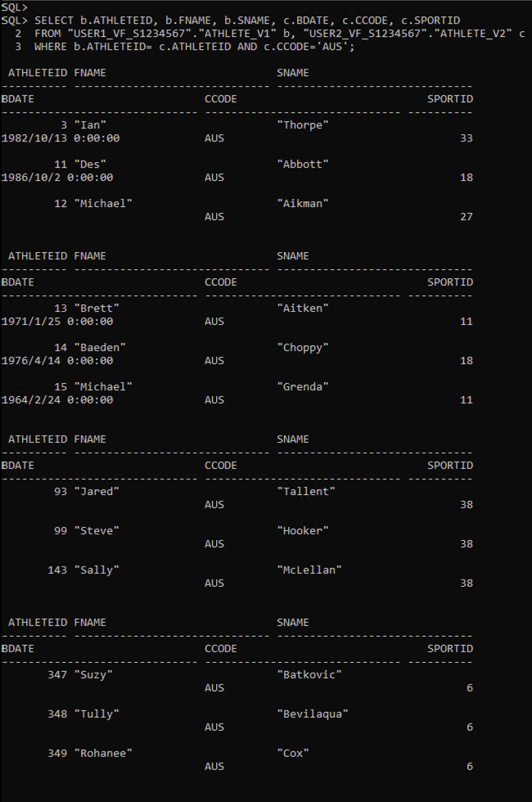

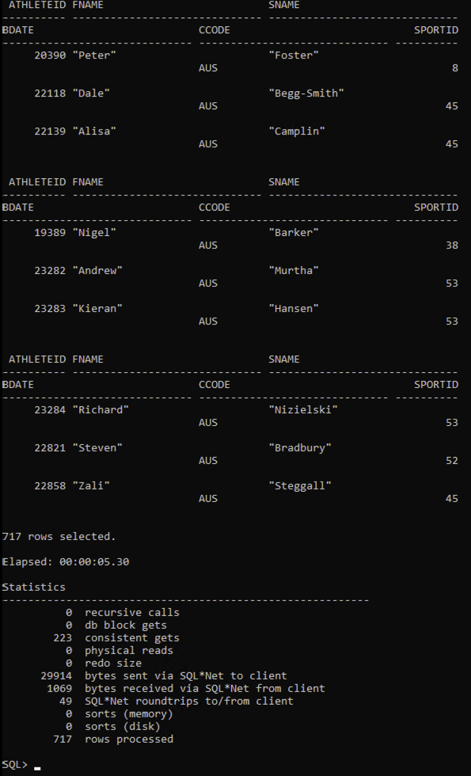

The data transmission cost of the inner-join execution plan is 29914 from “bytes sent via SQL*Net to client” in Statistics.

- Semi-join Execution Plan

Step 1 – Perform the semi join on USER2

SELECT ATHLETEID
FROM "USER2_VF_S1234567"."ATHLETE_V2"
WHERE CCODE = 'AUS';

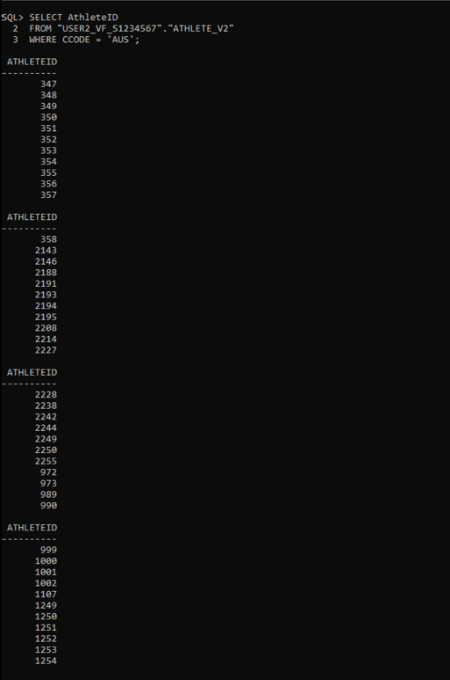

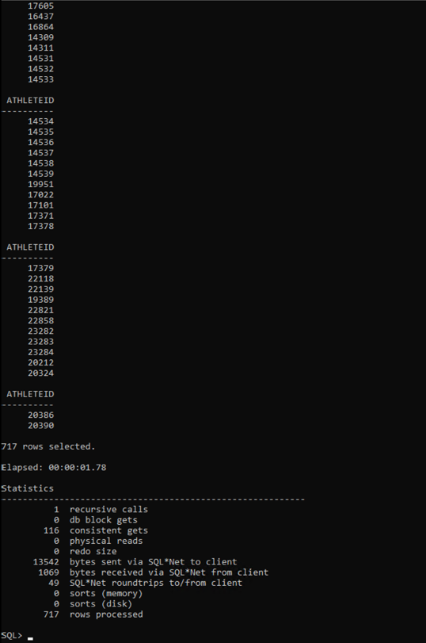

The data transmission cost is 13542 from “bytes sent via SQL*Net to client” in Statistics.

Step 2 - Perform the final join on USER

SELECT b.ATHLETEID, b.FNAME, b.SNAME, c.BDATE, c.CCODE, c.SPORTID
FROM "USER1_VF_S1234567"."ATHLETE_V1" b
JOIN (SELECT ATHLETEID, BDATE, CCODE, SPORTID
FROM "USER2_VF_S1234567"."ATHLETE_V2"
WHERE CCODE = 'AUS') c ON b.ATHLETEID = c. ATHLETEID;

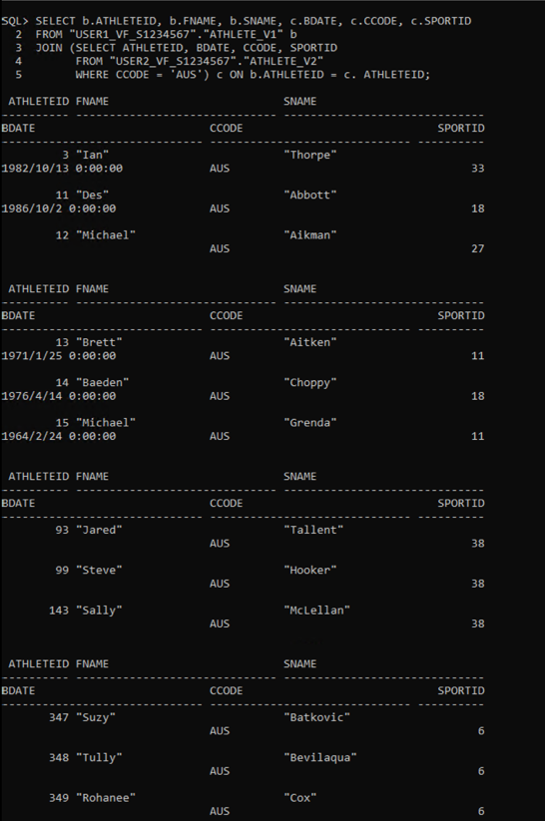

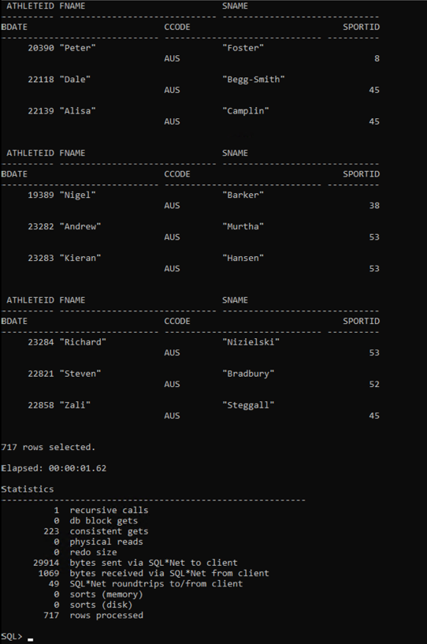

The data transmission cost is 29914 from “bytes sent via SQL*Net to client” in Statistics.

Therefore, the total data transmission cost of the semi-join execution plan is 13542 (step 1) + 29914 (step 2) = 43456, which is greater than the data transmission cost of the inner-join execution plan (29914). So, the inner-join execution plan is better and become my choice.

